Components:

* stats() returns a cross tabulated table of passengers that survived based on Pclass and sex.
* scat() returns various scatter plots that display the correlation between various features vs the outcome of passengers.
* class Perceptron returns the accuracy of the perceptron.
* z_input() returns the dot product of X vector and weight vector.
* weights() returns randomized weight vector composed of floats less than 1.
* predict() is step function which returns 1 if z is greater than or equal to 0, else returns 0.
* def fit() is activation function that measures the accuracy of the predictions and based off of the accuracy will then updated the weights to better predict the data. Also, returns the accuracy of the activation function and if chosen a list of the predictions.

Initially, I attempted to gain a visual understanding of the data through visual adds such as a scatter plot and cross tabular data. Through the visual analytics, it is clearly that there is a high correlation between sex and survival as females were more likely to survive in comparison to men. As displayed in the scatter plot diagrams returns via the scat() method, the titanic data seems to be non linear as there is a large variability in those that survived based on sex, pclass, age, fare, etc. Thus, as a perceptron is best used for linearly separable categorical data, it was hypothesized that the perceptron would have a poor accuracy for predicting survival of the passengers. Thus, I generated a single layer perceptron program that took the input data and predicted the passenger’s survival rate. With an epoch of 1000 and learning rate 0.001, the accuracy of my perceptron for the input titanic data is 57.9117%. In comparison to an epoch of 10000 and learning rate 0.0001, the accuracy of my perceptron for the input titanic data is 57.9124%. With an epoch of 10000 and learning rate 0.001, the accuracy of my perceptron for the input titanic data is 57.9124%. Therefore, my perceptron maintains a poor accuracy percentage despite the change in epoch and learning rate. I conclude that the perceptron is not the proper machine learning algorithm to predict the outcome of passengers. For an experiment in the future, I should test the titanic data with unsupervised learning clustering analysis neural network and other neural networks rather than a single layer perceptron which works best with clearly linearly separable data.

Returned Diagrams: Where blue indicates survived and red death

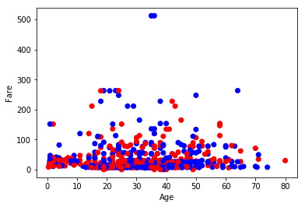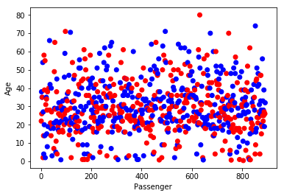

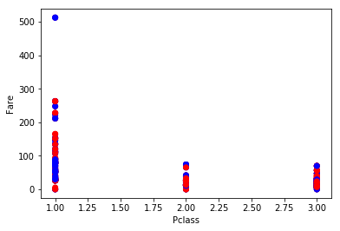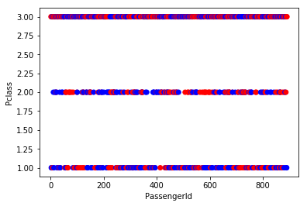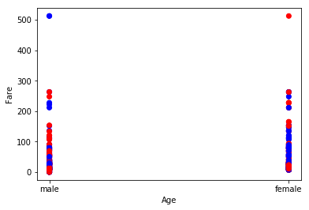

Survived Pclass Sex

0 1 female 3

male 77

2 female 6

male 91

3 female 72

male 300

1 1 female 91

male 45

2 female 70

male 17

3 female 72